Udacity Data Analyst Nanodegree Program

Project 1: Explore Weather Trends

Robert Bruton

Outline

1. Extract the data.

I used the following SQL query to get global data:

SELECT *

FROM global_data

I used the following SQL query to view list and find local city:

SELECT *

FROM city_list

WHERE country = 'United States'

I chose Jacksonville as it was nearest me. Use following SQL query to get Jacksonville data:

ELECT year, city, avg_temp

FROM city_data

WHERE city = 'Jacksonville'

I decided to also look at cities that represent both global and national extremes. I used the following SQL query to choose extreme cities:

SELECT city, avg_temp

FROM city_data

WHERE country = 'United States'

ORDER BY avg_temp

SELECT city, avg_temp

FROM city_data

ORDER BY avg_temp

I then chose Miami and Minneapolis as my national extremes and Ulaanbaatar and Khartoum as my global extremes. I used the following SQL query to get the data for these cities:

SELECT year, city, avg_temp

FROM city_data

WHERE city IN ('Miami', 'Minneapolis', 'Ulaanbaatar', 'Khartoum')

Data was downloaded as CSV files.

1. Open up the CSV.

After downloading the data as CSV files, I opened the CSV files in Excel. I then cleaned up and combined the data into 1 organized Excel file.

1. Create a line chart.

I chose the maximum data range for each comparison based on the lowest maximum range without missing data of the cities in the comparison.

I then computed 10-year moving averages for each data set. Moving averages were calculated by using the built in Excel function “AVERAGE” on the first 10 cells in the annual averages column for the first moving average calculation and then copying that formula into the following cells in the moving averages column as shown in the screenshots below:

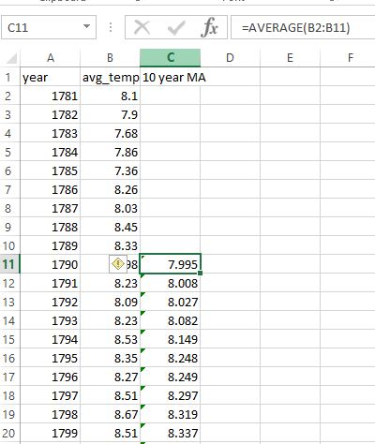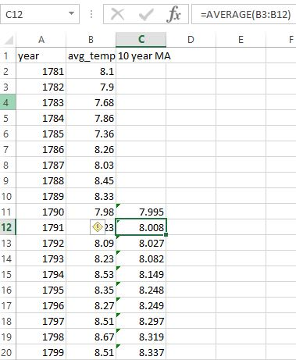

For the global vs local comparison, I made a line chart of the 10-year moving averages for global and local (Jacksonville) temperatures from 1790 to 2013 (starting in 1790 since there was a lot of missing data pre 1781 and using a 10-year moving average).

For the global vs extremes comparison, I made a line chart of the 10-year moving averages for the global temperature and the temperatures of my global and national extreme representative cities. For this comparison I used the range of 1878 to 2013 since there was no data pre 1869 for Khartoum and the 10-year moving average takes 10 years off the beginning.

For both graphs, I used what I felt to be appropriate axis values and steps to best display all the data.

1. Make observations.
2. Compared to the average annual global temperatures, my areas local average annual temperatures are much higher. This makes sense as I live in the southernmost state of the United States (Florida) where the climate is closer to sub tropic than temperate. Looking at the trend over the past 200 plus years, this difference has been fairly consistent. The average difference is about 12.7°C and the range between the max and min difference is 1.321°C which is only 10% of the average difference.
3. The change in my local temperature over time has followed the same trend as the global temperature. The plot shows a near identical trend.
4. The overall trend of the global, as well as the local, temperature is an increase. This trend has remained mostly consistent over the past couple hundred years. There have been some times when the temperature has been decreasing, but this has only occurred in a relatively short time line while the long term shows a steady rise in the annual temperatures.
5. Comparing the global temperature with that of my national and global extreme cities shows a similar trend overall with all cities and the world increasing gradually. My national high extreme city, Miami, shows the least overall increase, but it is still an increase. There does not really seem to be any significant difference between the global trend and that of locations with extreme highs or lows, they all trend up at a similar rate.